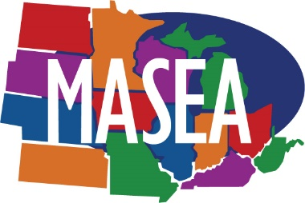
Midwest Association of Student Employment Administrators
2023 Student Employee of the Year

CAMPUS NOMINATION FORM

Student Nominee’s First & Last Name: ____________________________________________________________________
Student Nominee’s Email Address:_______________________________________________________________________
Student Nominee’s Job Title:____________________________________________________________________________
SEOTY Nomination Category: Community Service Diversity Leadership Tech & Innovation Critical Thinking

Supervisor’s Name: __________________________________ Supervisor’s Email:_________________________________
Department where student position is held: ___________________ ____________________________________________
Nominating Institution: __________________________ _____ Is Institution 2 year or 4 year:_______________________
Submitting MASEA Member: ______________________________ MASEA Member Phone: ________________________
MASEA Member Email: _______________
Please Note: All letters and awards will be sent directly to the submitting MASEA member for distribution to your student.
MASEA Mailing Address ____________________________ City ____________________ State _______________
Name of Institution President: _______________________ Student Email: ______________________________________
Total number of nominations received at your institution: ________

Please visit https://masea.org/SEOTY/ for eligibility criteria, submission instructions, and more.

All nominations must be submitted via email to info@masea.org by 11:59pm CST March 1, 2023.

Contact Information
Contact info@masea.org with any questions.

Nominations should be in letter format (2 page maximum-this does not include the cover letter page) and include the following requirements:
- Briefly describe why you are submitting the student for recognition
- Briefly outline your student employee's accomplishments over this past year and/or how they have contributed to the work place.
- How does this student exhibit NACE competencies in their position? Please provide specific examples. (Visit www.masea.org for information on the NACE competencies)
- Closing statement

